Running a Migration with No Previous Work Done v.2

1. Create the SharePoint Online site
   1. Login to portal.office.com
   2. Click the **Waffle** button in the upper left hand corner, and then choose **Admin**
   3. Under Admin Centers, choose SharePoint
   4. Under Sites, click on Active Sites
   5. On the search bar, type in the Alias for the site you want to create and press Enter
   6. **If the site exists**, follow **steps g-n**. **If it does not** exist, skip to **step o**.
   7. Select the site, and from the toolbar choose **Hub**, then **Change Hub Association**.
   8. Under Select a Hub, click the drop down, and choose **None** at the top, then click Save.
   9. Now with the site still selected, click the **ellipses** next to Hub, then click **Delete**. Click OK on the pop-up. Wait about 5 minutes for SharePoint Online to register that the site has been deleted.
   10. Go to one of the servers, either dhhs-devsp3 or dhhs-spdev2 and login. Right click on **Windows Powershell** and click **Run as Administrator**.
   11. From the prompt, type or paste the following command: **Connect-SPOService -Url** [**https://schhs-admin.sharepoint.com**](https://schhs-admin.sharepoint.com)
   12. Enter your credentials in the pop-up.
   13. You will be returned to the prompt. From here, type/paste the following command, with the alias of the site to delete in place of ALIAS: **Remove-SPODeleted Site -Identity** [**https://schhs.sharepoint.com/sites/ALIAS**](https://schhs.sharepoint.com/sites/ALIAS)
   14. When it asks to confirm, press Enter, or type Y and press Enter. Now, it can take anywhere from 10 minutes to 2-3 hours for the alias to become available. If it does not, you will need to choose a new Alias for the site and proceed to the next step.
   15. **From SharePoint Admin Center under Active Sites,** click **Create** from the toolbar.
   16. In the Dialog, scroll down and click **Other Options.** In the next window, make sure Team Site is selected from the drop down. Type in the title of the site, and edit the box below it and type in the correct alias. Then click Create.
2. **Create the Sharepoint Groups in the New SharePoint Online site/Rename the HomePage**
   1. Navigate to the new site you just created, and open another tab, and navigate to the 2010 version of the site as well.
   2. Go to **Site Actions, Site Permissions** on the 2010 site.
   3. On the SPO site, Go to the **Gear Icon**, and then click **site permissions**, and **Advanced Permission** settings.
   4. On the SPO site, create each of the groups you see on the 2010 site. Name them exactly as they are on the 2010 site. To create the group, select **Create Group** from the toolbar, type in the name, and it does not matter what permission level you set – the migration will change it. Then click **Save**.
   5. Back on the 2010 site, each group Owner must be set to an individual. Click the Group Name on each of the groups listed on the 2010 site, and under group Owner, change it to an individual. Then click **Save**.
   6. On the SPO site, click the **Gear Icon**, and then **Site Contents**.
   7. Scroll down to the **Site Pages** and click on it.
   8. Click the **ellipses** next to the name Home.aspx. Choose **Rename** from the dialog. Rename the home page to **Home1**. This will ensure that the Home Page of the 2010 site gets copied over.
3. Migrate the 2010 Site Permissions and Content
   1. Log on to one of the servers with your credentials. Open Sharegate.
   2. Click Copy on the left hand side. Then, on the screen from the right, click **Copy Structure**.
   3. On the next screen, paste in the URL of the 2010 site to migrate. Leave Authentication set to **Current User** and click **Connect**. On the next screen, make sure the Top Level site is selected, and click **Next**.
   4. On Destination, paste in the URL of the SPO site. Under Authentication, set it to **Browser**. Click **Next**.
   5. Enter your username on the next screen, click next, and put in your RSA token.
   6. Once the site comes up, click next.
   7. On the next screen, select the **Groups** icon from the left hand side:  
      
   8. Select each of the groups to migrate from the left, you can select multiple groups by holding down the CTRL key. These groups should match what is on the right hand side. See below:  
      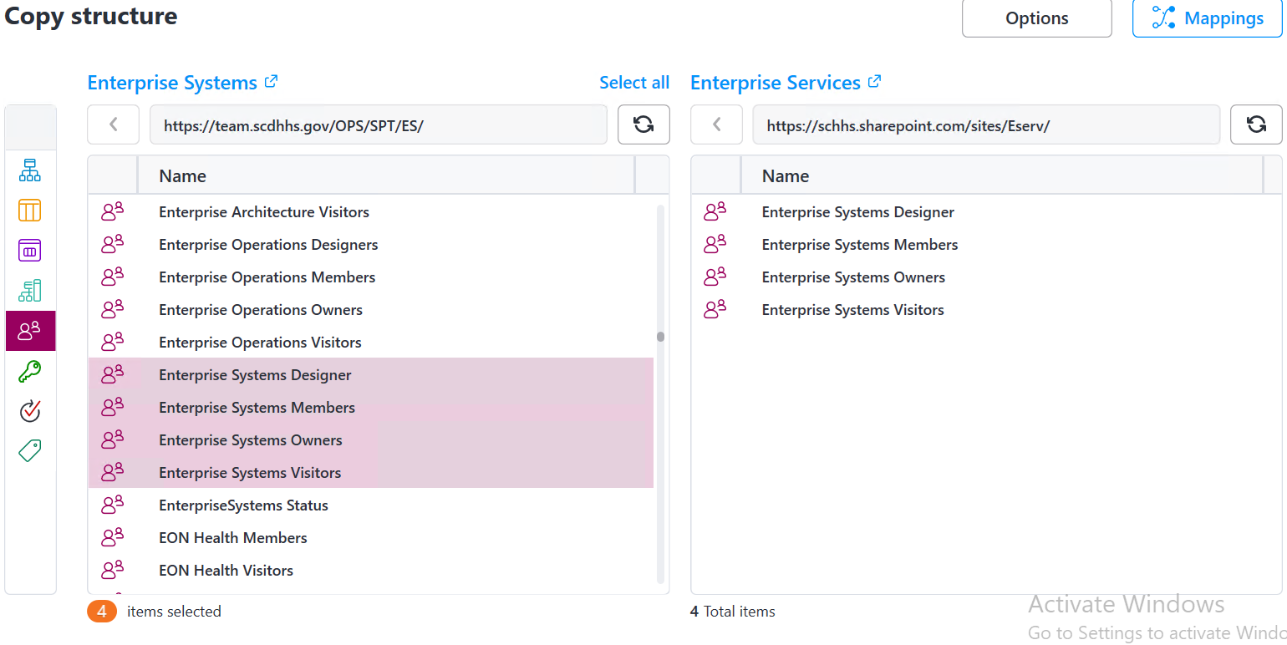
   9. Now, click **Mappings** on the upper right hand side.
   10. On the mappings screen, in the search box on the Right, type in **spnouser**
   11. Drag spnouser to the first box next to Unresolved Users and groups. See below**:**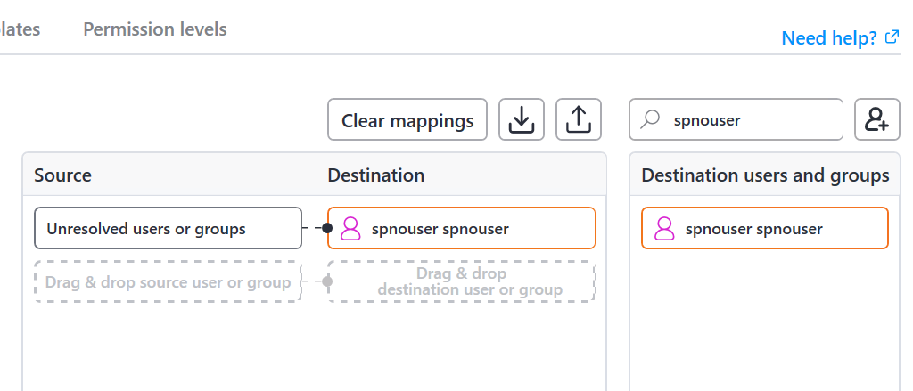
   12. Now, on the left hand side, type in the groups that need to be migrated, and search for the respective SPO group on the right hand side, and drag them next to each other as shown below:  
       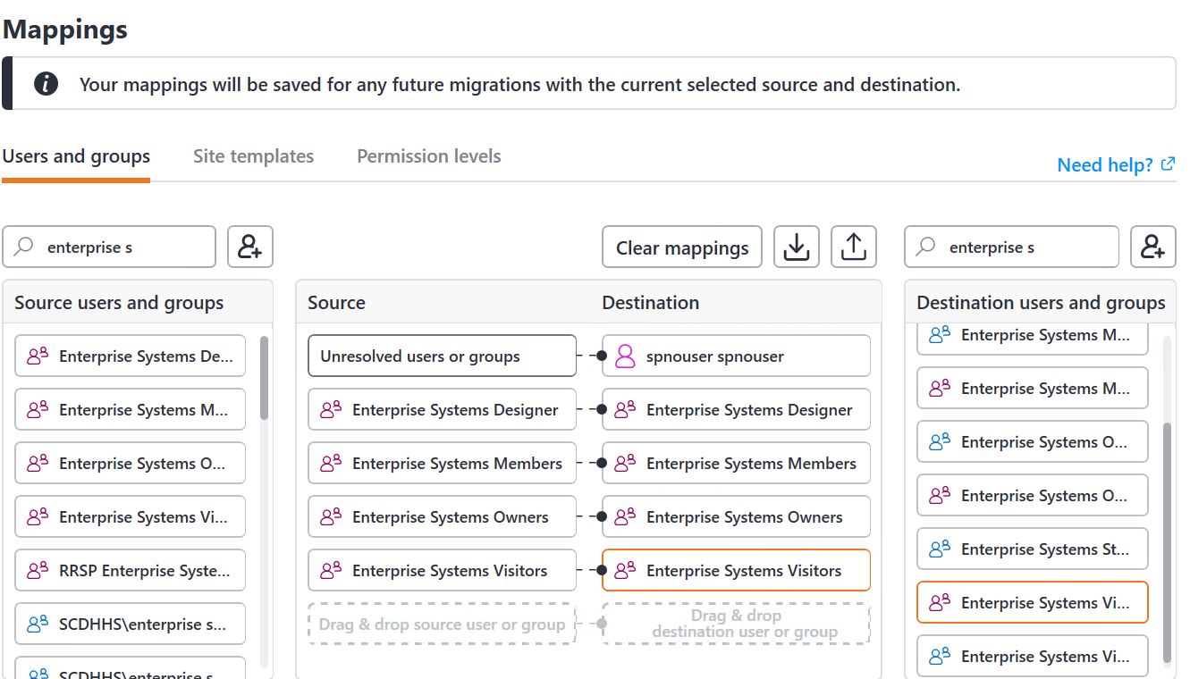  
       TIP: MAKE SURE all the groups you place in the mapping have a **PURPLE** person icon next to them. Blue icons are O365 groups/AD groups, and you do not want to use those.
   13. Click the **Export** icon as show below to save the mapping so you don’t have to create it again. Just save it as ALIASUsersandMappings.sgum under the Permissions Folder on C:\TEMP.  
       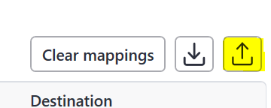
   14. Click **Save**.
   15. Back on the other screen, click **Start Copy** to copy the permissions.
   16. Once this has finished, on the Copy Permissions screen, click the **Back** button in the lower left. (if you get disconnected, repeat steps A-F above).
   17. Now, select the top blue **Sites** icon from the left hand side.
   18. Select the site from the left hand dialog, then click **Options** next to Mappings at the top.
   19. Under Action to Perform, choose **Merge**. See below:  
       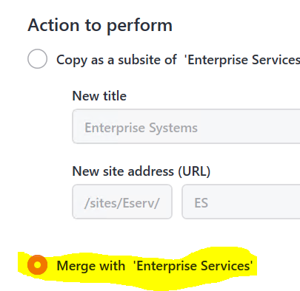
   20. Under Operation Mode, click the drop down and choose **Copy if Newer (incremental)**. See below:  
       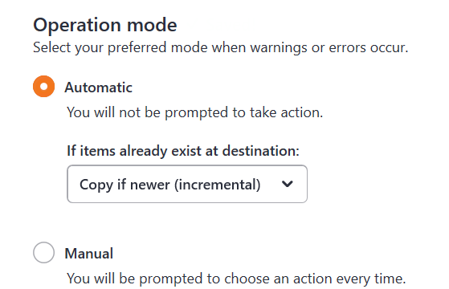
   21. Under Configurations, uncheck the boxes next to Workflows and Subsites, and check the box to Set Lists to modern Experience. See below:  
       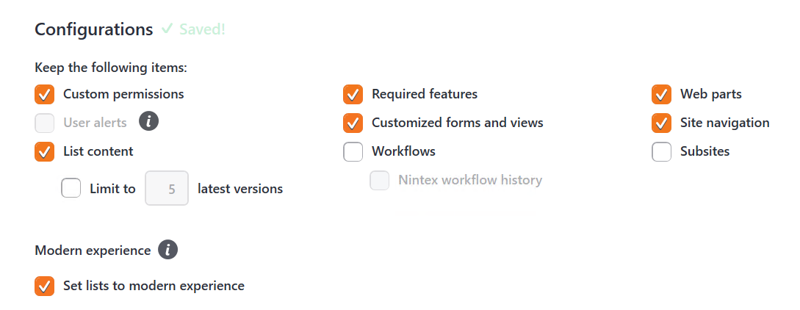
   22. Now click the **CheckMark circle** in the upper right hand corner to close the Options dialog. Back on the previous screen, click **Start Copy** in the lower right.
   23. Wait for the migration to finish, and then go check the new SPO site to make sure the home page, and all list/library content, and site permissions copied over. **NOTE: If the site home page Does Not copy over during the incremental properly, follow these steps**:
   24. Go to the Site Pages on the SharePoint online site. Click the ellipses next to Home.aspx, and click Delete.
   25. Connect to the site in Sharegate again using the above steps.
   26. Once at the main screen, instead of selecting the Site Icon from the left hand side, select the Lists and Libraries icon below it. See below:  
       
   27. From here, scroll down in the box on the left and select Site Pages. Do the same in the box on the right, so that Sharegate looks like this:  
       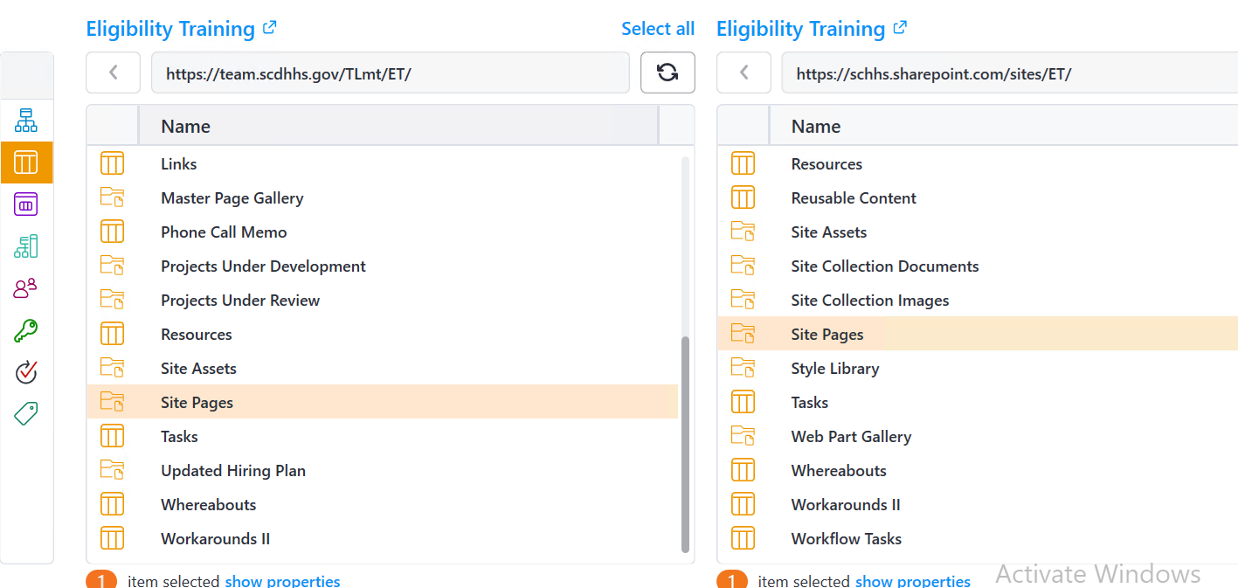
   28. Click Options, and choose merge, and uncheck all the boxes except List Content.
   29. Click Start Copy. This will get the correct homepage to copy over.
   30. When the correct homepage gets copied in, you will find that the Logo picture appears to be a broken link. To fix this, go to the Gear Icon, click Site Contents, and on the Site Contents screen, click on Site Settings from the grey toolbar, which is on the right hand side.
   31. Under Look and Feel on the right hand side, select the top option for Title, Description and Logo.  
       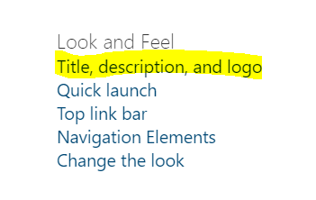
   32. On the next screen, delete the text in the From Computer box as shown below, and click OK.  
       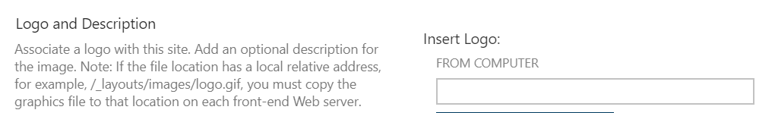
   33. This should remediate the site home page issues if any.
4. Run the Site Page Modernization script and Add the Site to the Hub
   1. Logon to dhhs-devsp3 and run Powershell as Administrator.
   2. Type in cd C:\TEMP\Modern in the prompt.
   3. Open File Explorer, and navigate to the above folder (C:\TEMP\Modern)
   4. Right click on Page.ps1, and click Open With.
   5. Accept the Notepad option and click OK.
   6. Under the following line, change the site URL after the /sites/ to be the alias of the new SharePoint Online site. See below:  
      **# Connect to the web holding the pages to modernize**

**$Connection = Connect-PnPOnline -Url https://schhs.sharepoint.com/sites/SITE   
-SPOManagementShell**

* 1. Click File, Save, and make sure to close the notepad file.
  2. Back in Powershell, type the following: .\page.ps1 and press Enter. You should see the following:  
     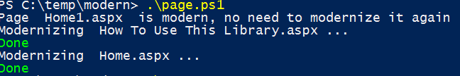
  3. Go back to the SharePoint Online site, and go to the Site Pages.
  4. Click the ellipses next to the newly created **Migrated_Home.aspx**
  5. Select Make HomePage from the drop down. This will set the modern page to the home page.
  6. Now, open navnodes.xlsx
  7. Find the site on the navnodes.xlsx list, and under the Header column, make note of the Hub name.
  8. Open the SharePoint Admin center by going to <https://schhs-admin.sharepoint.com/>
  9. Click on Active Sites from the left hand navigation.
  10. On the grey toolbar, in the search box, type in the Alias for the SharePoint online site. E.g. Eligibility Training’s Alias Is ET, so in this example I would type ET into the search box and hit Enter. Sometimes it takes a minute or so to complete the search.
  11. Select the site, and from the grey toolbar, click Hub. On the drop down, click Associate with a Hub Site.
  12. In the pop out screen, from the drop down, choose the option that matches what was in the Header column on the Navnodes spreadsheet.
  13. It may take 15-20 minutes for the changes to take effect. After this time, navigate to the SharePoint online site and make sure the Hub navigation appears at the top.
  14. Run the theme script to apply the theme to the site from the server using powershell.

This concludes the document on Running a Migration.